

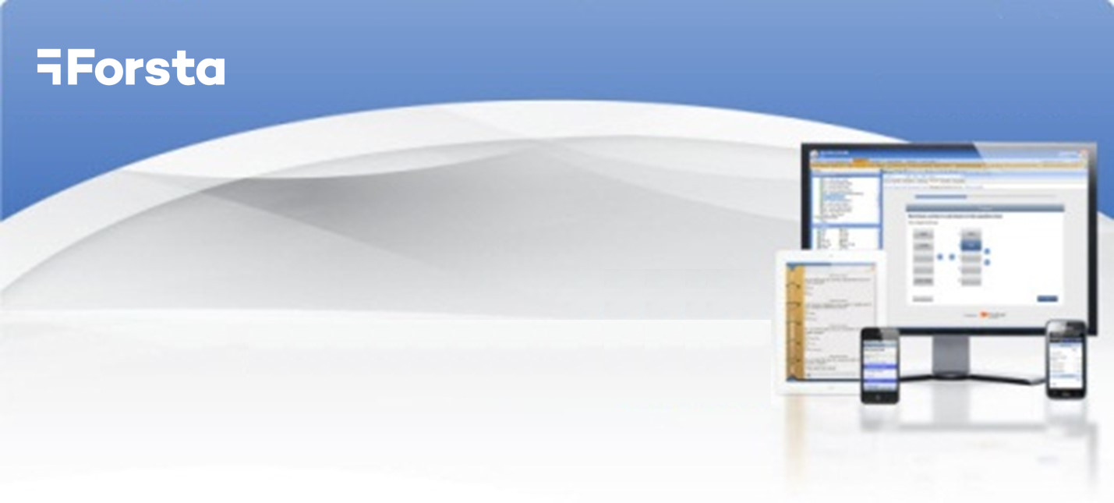

Forsta Open Dialer Interface

Forsta Open Dialer Interface

Contents
Definitions 3
Common schema or How does it work 4
What Forsta CATI must supply to the dialer provider 4
What the dialer provider must supply 4
Scalability 5
Dialer driver assembly implementation 5
Forsta Open dialer interface assembly structure 6
Workflow 7
Instantiation 7
Initialization 7
StartCampaign / Stop campaign 8
Agent login / Agent logout and agent ready status 8
Interview cycle in automatic/preview dialing modes 10
Interview cycle in predictive dialing mode 10
Hybrid dialing in predictive dialing mode 11
Dialer health control 12
Dialer parameters 13
Dialer logs Access 17

Definitions

The following terms are used in this document (they are marked in Bold throughout the document).
Agent – a person working with the dialer as an interviewer
Agent group – a group of agents which has its own identifier
Campaign – corresponds to Forsta CATI survey
Forsta CATI – an add-on to Forsta which provides CATI (Computer Assisted Telephone Interview) functionality
Forsta open dialer interface assembly – an assembly (dll file) supplied by Forsta to Dialer providers. This assembly contains definitions of all common constants, enumerations, classes, exceptions, interfaces.
Forsta dialer WS (Forsta dialer web service) – Forsta CATI interacts with the dialer through this web service.
Forsta open dialer interface – a set of interfaces and classes providing interaction between Forsta CATI and the Dialer provider
Dialer – (in this document) a dialer provided by the Dialer provider
Dialer driver assembly – an assembly (dll file) provided by the Dialer provider to Forsta. This assembly implements Forsta open dialer Interface and function inside Forsta dialer WS.
Dialer provider – a company which uses Forsta open dialer interface to attach its own dialer to Forsta CATI

Common schema or How does it work
Forsta CATI interacts with the dialer via Forsta dialer web service.

What Forsta CATI must supply to the dialer provider
Forsta CATI provides:
- Public Forsta open dialer interface assembly <ConfirmitDialerInterface.dll> which contains definitions of all interfaces and classes required for Forsta CATI <-> Dialer interaction.

What the dialer provider must supply
In order to integrate a dialer into Forsta CATI the dialer provider should supply:

- Dialer driver assembly (example: ProviderDialer.dll) which implements Forsta open dialer Interface
- Dialer driver assembly main class name and name space
Example:
Namespace "NewDialer.Dialer"
Main class "NewDialerLibrary"
(This information allows Forsta dialer WS to create an instance of the Dialer driver object.)
- A file in XML format containing the dialer parameters
- Dialer configuration parameters
- Dialer default campaign parameters
See Dialer parameters for details.

Scalability
If the Dialer is able to work with a large amount of interviewers simultaneously then Dialer provider should pay special attention to the stateless implementation of the Dialer driver assembly.
Forsta CATI uses a number of Forsta dialer Web Services running in parallel when it works with powerful dialers. Note that commands and notifications can be routed through different servers, for example dial command can go via server 1 and response outcome notification can go via server 2.

Dialer driver assembly implementation
Forsta provides the Forsta open dialer interface assembly.
To access all interaction interfaces and common classes the Dialer driver assembly must include reference to Forsta open dialer interface assembly:
Dialer driver assembly implements IDialerCore and IDialerRecording interfaces and uses IDialerEvents interface for notifications directed from the dialer to CATI:

Forsta Open dialer interface assembly structure
The schema below shows the contents of the Forsta open dialer interface assembly.
Details regarding all Open dialer interface assembly elements are available in a separate help file.

Workflow

Instantiation
First Forsta dialer WS creates an instance of the Dialer driver object. It always uses a constructor with the next signature:
public SomeDialerDriver(IDialerEvents dialerEvents, ILogger logger);

Parameters:
dialerEvents - Dialer uses this reference to send notifications to Forsta CATI
logger - Dialer can use this logger to log messages into Forsta CATI log.
So Dialer driver assembly main class must have a constructor with such signature.

Initialization
Dialer driver assembly provides two interfaces:
  - IDialerCore
  - IDialerRecording
For each interface Forsta CATI first calls the Initialize method. Then it can call other interface methods.
Forsta CATI can call the Initialize method several times; it does call the Initialize method each time Confrmit CATI backend service starts.
There is a set of IDialerCore methods that Forsta CATI can call at any time, even before Initialize. These methods are used to configure common properties of the dialer:
string GetName() – returns Dialer name in order to show it in CATI supervisor. Ex.: TCI.
string GetVersion()– returns Dialer version to show it in CATI supervisor. Ex.: 1.0.
ValidateConfigurationParameters(string parametersXml) – checks that parametersXml contains correct dialer configuration parameters.
SetConfigurationParameters(string parametersXml) – configures the dialer with the new parameters.

StartCampaign / Stop campaign
Forsta CATI sends StartCampaign command when the corresponding survey is opened in Forsta. StartCampaign is a synchronous method. It means that Forsta CATI does not expect any asynchronous notification from Dialer, as soon as the method returns successfully the corresponding campaign is considered by Forsta CATI as opened.
Forsta CATI sends StopCampaign command when the corresponding survey is closed in Forsta. StopCampaign is a synchronous method as well.
Note
Dialer must not immediately logout agents working with the campaign when the campaign is stopped. It must allow the logged in agents to finish their current calls and it must stop delivering new calls for the campaigns.

Agent login / Agent logout and agent ready status
Depending on the agent task choice in Forsta CATI agent can login either to a particular campaign or not. Login and Logout operations are asynchronous, Dialer informs Forsta CATI that login or logout operation is finished via IDialerEvents.NotifyAgentState method.
As soon as an agent is logged in Forsta CATI calls GoReady method to make the agent available for calls.
Note
If agent is logged in in predictive dialing mode then Forsta CATI calls SetGroups method just before GoReady to tell Dialer what agent groups the agent belongs to.
During the agent session Forsta CATI can call GoNotReady to make the agent not available for calls, and GoReady to return the agent back to working state. GoReady and GoNotReady operations are synchronous.
Note
Forsta CATI calls GoNotReady only when the agent is not on a call. Forsta CATI can also make agent not ready at CompleteCall operation (setting makeAgentReady parameter to false)

Interview cycle in automatic/preview dialing modes
Interview cycle in automatic and preview dialing modes looks like as follows:

Interview cycle in predictive dialing mode
As soon as a campaign is started in predictive dial mode Dialer can request Forsta CATI for calls, Dialer calls RequestCalls each time it needs more calls, Forsta CATI answers each request with SendNumbers. If there are no calls to dial SendNumbers method contains empty call list.Dialer tries to call the numbers, when a call is connected Dialer assigned the call to an agent and interview starts. When interview is finished Forsta CATI calls CompleteCall:

Hybrid dialing in predictive dialing mode
While a campaign is opened in predictive dialing mode some calls can be dialed in preview dialing mode. Such behavior is called hybrid dialing, and such calls are called hybrid calls. Here are the hybrid dialing steps:
- Dialer requests calls via IDialerEvents.RequestCalls method.
- Forsta CATI answers via IDialerCoreApi.SendNumbers, some calls in the call list can have dialing mode = DialingMode.Preview, such calls are to be considered by dialer as hybrid calls.
- Dialer does not immediately dial hybrid calls. Instead of it dialer waits for any available agent for this call, and as soon as the agent is found dialer “attaches” the agent to the call and notifies Forsta CATI that call is ready for dialing via IDialerEvents.ScreenPop message.
- Now Forsta CATI can make real call to the respondent via IDialerCoreApi.CompletePreview command. But Forsta CATI is not obliged to call CompletePreview. It can miss this step.
- Forsta CATI sends IDialerCoreApi.CompleteCall to complete the call and release the agent for the next calls.
- Later on Forsta CATI sends IDialerCoreApi.UpdateInterviewStatus to inform Dialer about the final interview status.
And here is the hybrid dialing workflow diagram:

Dialer health control
To ensure that the dialer is operational Forsta CATI repeatedly calls IDialerCoreApi.GetState.
When a value DialerState.Available is returned, it indicates that the dialer is “alive”.
If the dialer returns DialerState.Unavailable or the GetState call fails then Forsta CATI tries to call GetState again and again during specified time interval. If GetState call still returns DialerState.Unavailable after the specified time interval expires, Forsta CATI assigns dialer the “unavailable” state and calls IDialercoreApi.Release.
The dialer can also use IDialerEvents.NotifyDialerState to notify Forsta CATI about dialer state change.

Dialer parameters
Forsta CATI stores two types of dialer parameters in its own database:
  - Dialer configuration parameters
  - Dialer campaign parameters
The following IDialerCoreApi functions work with dialer parameters:
Dialer configuration parameters:
SetConfigurationParameters(string companyId, string configurationParametersXml)
Dialer campaign parameters:
SetCampaignParameters(
string companyId,
int campaignId,
DiallingMode dialingMode,
string campaignParametersXml)
The Dialer provider supplies an XML file containing the default configuration and campaign parameters in the following format:
<DialerConfigurationParameters>
<DialerParameter>
<Id>… </Id>
<Name>… </Name>
<Value>…</Value>
<Type>… </Type> - A .Net simple type is required here: String, Boolean, Int32.
<MinValue>…</MinValue> - if applicable
<MaxValue>…</MaxValue> - if applicable
<PossibleValues>…</PossibleValues > - if applicable
<Visible/>…</Visible> - True or False. True means the parameter is visible in CATI Supervisor
<Editable/ >…</Editable > - True or False. True means the CATI supervisor can edit the parameter value.
</DialerParameter>
<DialerParameter>
…
</DialerParameter>
</DialerConfigurationParameters>
<DialerCampaignParameters>
<DialerParameter>
<Id>… </Id>
<Name>… </Name>
<Value>…</Value>
<Type>… </Type>
<MinValue>…</MinValue>
<MaxValue>…</MaxValue>
<PossibleValues>…</PossibleValues >
<Visible>…</Visible>
<Editable >…</Editable >
</DialerParameter>
<DialerParameter>
…
</DialerParameter>
</DialerCampaignParameters>

Example:
<DialerParameter>
<Id>MaxRings</Id>
<Name>No reply timeout (no. of rings) </Name>
<Value>5</Value>
<Type>System.Int32</Type>
<MinValue>0</MinValue>
<MaxValue>10</MaxValue>
<Visible>True</Visible>
<Editable >True</ Editable>
</DialerParameter>
<DialerParameter>
<Id>AnsMachineDetect</Id>
<Name>Enable answer phone detection</Name>
<Value>False</Value>
<Type>System.Boolean</Type>
<Visible>True</Visible>
<Editable >True</ Editable>
</DialerParameter>
Forsta CATI validates parameters according to MinValue/MaxValue/PossibleValues and passes parameters in XML format to Set Parameters functions. If any parameter value is incorrect the dialer throws DialerParametersException which contains an enumeration of the DialerParameterError objects.

Note
The following parameters are obligatory, non-editable and hidden. The supplied XML file must always contain the configuration parameters listed below. These parameters have more simple structure – just name/value pairs. The parameter values depend on the particular dialer implementation:
SupportedPersonModes – comma separated list of agent task choice modes which the dialer supports. Possible task choice modes are: Automatic, Manual, CampaignAssignment:
<SupportedPersonModes> Automatic,Manual,CampaignAssignment</SupportedPersonModes>

IsReloginNeededOnCampaignChange – Does the dialer require the agent to re-login when the agent switches to another campaign?
<IsReloginNeededOnCampaignChange>True</IsReloginNeededOnCampaignChange>

IsHangUpSupported – Does the dialer support the hang-up command?
<IsHangUpSupported>True</IsHangUpSupported>

IsPauseOrResumePlaybackSupported – Does the dialer support pause/resume operation during voice fragment playback?
<IsPauseOrResumePlaybackSupported>False</IsPauseOrResumePlaybackSupported>

IsToggleAgentListensToPlaybackOrRespondentSupported –Does the dialer support switching voice source from the agent to file playback during voice fragment playback?
<IsToggleAgentListensToPlaybackOrRespondentSupported>True</IsToggleAgentListensToPlaybackOrRespondentSupported>

IsDynamicExtensionNumberAllowedForLocalAgents–Does the dialer allows entering interviewer extension number at local interviewer login?
<IsDynamicExtensionNumberAllowedForLocalAgents>False</IsDynamicExtensionNumberAllowedForLocalAgents>

IsDynamicExtensionNumberAllowedForRemoteAgents–Does the dialer allows entering interviewer extension number at remote interviewer login?
<IsDynamicExtensionNumberAllowedForRemoteAgents>False</IsDynamicExtensionNumberAllowedForRemoteAgents>

Dialer logs Access
Forsta CATI requires access to the dialer logs.
To that end Forsta open dialer interface uses a special ILogger interface with one function:
void Log (TraceEventType logLevel, string comment, string message)
Forsta CATI passes a reference to the logger via Dialer driver assembly main class constructor. See also Instantiation.

